**Single Country:**

To evaluate uncertainty with CA and its alternatives, we have presented 10 examples of circles with different percentages of uncertainty/CA for user perception. Then we have added a questionnaire section with five circles one after another and the task is defined as to determine the uncertainty based on prior perception for each circle and write the corresponding answer in percentage (x%) afterwards.

**Ca** Evaluation section**:**

**Examples in % for user perception:**  
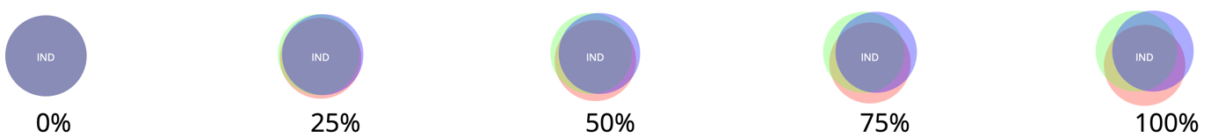

**Questionnaire:**

Q1. Estimate the uncertainty for the following circle in the range 10% to 100%

Answer:

Q2. Estimate the uncertainty for the following circle in the range 10% to 100%

Answer:

Q3. Estimate the uncertainty for the following circle in the range 10% to 100%

Answer:

Q4. Estimate the uncertainty for the following circle in the range 10% to 100%

Answer:

Q5. Estimate the uncertainty for the following circle in the range 10% to 100%

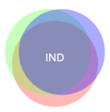

Answer:

**ca-static** Evaluation section:

**Examples in % for user perception:**

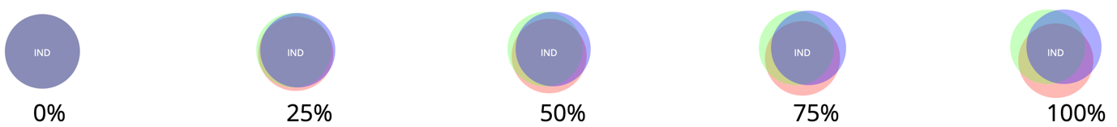

**Questionnaire:**

Q1. Estimate the uncertainty for the following circle in the range 10% to 100%

Answer:

Q2. Estimate the uncertainty for the following circle in the range 10% to 100%

Answer:

Q3. Estimate the uncertainty for the following circle in the range 10% to 100%

Answer:

Q4. Estimate the uncertainty for the following circle in the range 10% to 100%

Answer:

Q5. Estimate the uncertainty for the following circle in the range 10% to 100%

Answer:

**Blur** evaluation section**:**

**Examples in % for user perception:**

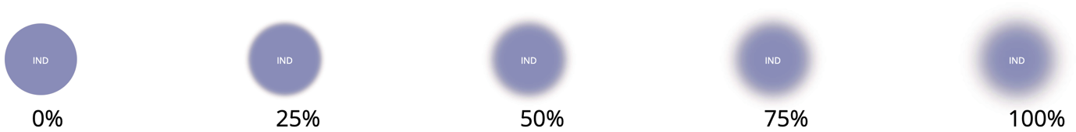

**Questionnaire**:

Q1. Estimate the uncertainty for the following circle in the range 10% to 100%

Answer:

Q2. Estimate the uncertainty for the following circle in the range 10% to 100%

Answer:

Q3. Estimate the uncertainty for the following circle in the range 10% to 100%

Answer:

Q4. Estimate the uncertainty for the following circle in the range 10% to 100%

Answer:

Q5. Estimate the uncertainty for the following circle in the range 10% to 100%

Answer:

**Noise** evaluation section:

**Examples in % for user perception:**

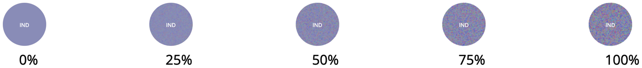

**Questionnaire:**

Q1. Estimate the uncertainty for the following circle in the range 10% to 100%



Answer:

Q2. Estimate the uncertainty for the following circle in the range 10% to 100%



Answer:

Q3. Estimate the uncertainty for the following circle in the range 10% to 100%



Answer:

Q4. Estimate the uncertainty for the following circle in the range 10% to 100%



Answer:

Q5. Estimate the uncertainty for the following circle in the range 10% to 100%



Answer:

**Bubble Chart with three Countries**

This chart is drawn with three countries only to gradually introduce the difference to the user. Since in previous section there was only one country, there was nothing to compare side by side but here in Figure-3 user can compare both uncertainties.

[**https://www.loom.com/share/415e1b6728ba49ecb04c2bb63b3ec1f3**](https://www.loom.com/share/415e1b6728ba49ecb04c2bb63b3ec1f3)

Figure-3: Bubble chart with three countries

1. United States (USA) shows maximum uncertainty among three.

|  |  |  |  |  |
| --- | --- | --- | --- | --- |
| Strongly  agree | Partially  agree | Neither agree nor disagree | Partially  disagree | Strongly  disagree |

1. Let say, USA has 100% uncertainty, then what will be for Brazil (BRA)?

|  |  |  |  |  |
| --- | --- | --- | --- | --- |
| 20% | 30% | 50% | 60% | 70% |

1. Let say, USA has 100% uncertainty, then what will be for India (IND)?

|  |  |  |  |  |
| --- | --- | --- | --- | --- |
| 30% | 50% | 60% | 70% | 80% |

1. Based on Figure-3 uncertainty is irrelevant to the number of infections.

|  |  |  |  |  |
| --- | --- | --- | --- | --- |
| Strongly  agree | Partially  agree | Neither agree nor disagree | Partially  disagree | Strongly  disagree |

**Bubble Chart with Ten Countries**

This is an extended version of Figure-3 where we have used data for 10 countries. All three countries from the earlier Figure-3 are also here but the order of uncertainties has been changed and that is especially noticeable here.

<https://www.loom.com/share/809941ba49e14d2997f393dc4172de8e>

Figure-4: Bubble chart with ten countries

**8. Select the degree to which you agree or disagree with each of the following statements:**

1. Germany (DEU) shows maximum uncertainty among tens.

|  |  |  |  |  |
| --- | --- | --- | --- | --- |
| Strongly  agree | Partially  agree | Neither agree nor disagree | Partially  disagree | Strongly  disagree |

1. Cuba (CUB) shows minimum uncertainty among tens.

|  |  |  |  |  |
| --- | --- | --- | --- | --- |
| Strongly  agree | Partially  agree | Neither agree nor disagree | Partially  disagree | Strongly  disagree |

1. To determine maximum uncertainty between Argentina (ARG) and Spain (ESP) is ambiguous.

|  |  |  |  |  |
| --- | --- | --- | --- | --- |
| Strongly  agree | Partially  agree | Neither agree nor disagree | Partially  disagree | Strongly  disagree |

1. Still in Figure-4 uncertainty is irrelevant to the number of infections (Circle size) of the countries.

|  |  |  |  |  |
| --- | --- | --- | --- | --- |
| Strongly  agree | Partially  agree | Neither agree nor disagree | Partially  disagree | Strongly  disagree |

**Bubble Chart With 50 Countries:**

In this Figure-4, we have utilized data for 50 countries. Since the chart is zoomable, we have not shown label for the smaller circumference countries due to insufficient space to accommodate and can be zoomed-in to see the corresponding label of the country. We are skipping those countries to make any question regarding them.

Figure-4: Bubble chart for 50 countries

**10. Select the degree to which you agree or disagree with each of the following statements:**

1. United States (USA) shows maximum uncertainty among all countries.

|  |  |  |  |  |
| --- | --- | --- | --- | --- |
| Strongly  agree | Partially  agree | Neither agree nor disagree | Partially  disagree | Strongly  disagree |

1. Quite impossible to determine the minimum uncertainty country.

|  |  |  |  |  |
| --- | --- | --- | --- | --- |
| Strongly  agree | Partially  agree | Neither agree nor disagree | Partially  disagree | Strongly  disagree |

1. Second and third largest uncertainty countries are still confusing.

|  |  |  |  |  |
| --- | --- | --- | --- | --- |
| Strongly  agree | Partially  agree | Neither agree nor disagree | Partially  disagree | Strongly  disagree |

1. Kazakhstan (KAZ) has higher uncertainty than Turkey (TUR)

|  |  |  |  |  |
| --- | --- | --- | --- | --- |
| Strongly  agree | Partially  agree | Neither agree nor disagree | Partially  disagree | Strongly  disagree |

1. Difficult to justify with naked eye if some countries have uncertainties like Israel (ISR).

|  |  |  |  |  |
| --- | --- | --- | --- | --- |
| Strongly  agree | Partially  agree | Neither agree nor disagree | Partially  disagree | Strongly  disagree |

1. Uncertainties of the countries are irrelevant to the number of infections (size of circle).

|  |  |  |  |  |
| --- | --- | --- | --- | --- |
| Strongly  agree | Partially  agree | Neither agree nor disagree | Partially  disagree | Strongly  disagree |

**Streamgraph (filled with color)**

**Description:** This stream graph is filled with color. Each color flow in the graph is named as stream and that represents a country. On mouse hover each stream shows the corresponding country name as tooltip. Intensity of colors do not have any relation with uncertainty. Along x-axis it represents date and y-axis represent the counts.[**https://www.loom.com/share/27cf835469e449288a03e0f731b0956b**](https://www.loom.com/share/27cf835469e449288a03e0f731b0956b)

**Figure-5: Colored Streamgraph**

**12. Select the degree to which you agree or disagree with each of the following statements:**

1. It is very easy to distinguish the flow for each country.

|  |  |  |  |  |
| --- | --- | --- | --- | --- |
| Strongly  agree | Partially  agree | Neither agree nor disagree | Partially  disagree | Strongly  disagree |

1. There are unique colors for each country.

|  |  |  |  |  |
| --- | --- | --- | --- | --- |
| Strongly  agree | Partially  agree | Neither agree nor disagree | Partially  disagree | Strongly  disagree |

1. Identification of some countries are difficult.

|  |  |  |  |  |
| --- | --- | --- | --- | --- |
| Strongly  agree | Partially  agree | Neither agree nor disagree | Partially  disagree | Strongly  disagree |

1. Same color in different stream refers to same country.

|  |  |  |  |  |
| --- | --- | --- | --- | --- |
| Strongly  agree | Partially  agree | Neither agree nor disagree | Partially  disagree | Strongly  disagree |

1. Red and bright colors are easily identifiable and those have higher uncertainties.

|  |  |  |  |  |
| --- | --- | --- | --- | --- |
| Strongly  agree | Partially  agree | Neither agree nor disagree | Partially  disagree | Strongly  disagree |

1. Top streams may have higher uncertainties than bottom stream countries.

|  |  |  |  |  |
| --- | --- | --- | --- | --- |
| Strongly  agree | Partially  agree | Neither agree nor disagree | Partially  disagree | Strongly  disagree |

**Texture Streamgraph**

This chart is generated from the Figure-5 by just replacing the filling color with textures where still texture maintains colored stream flow. Axes presentations are same as that of colored fill version. Streamgraph link above includes this part. **Background pattern
**

**Figure-6: Streamgraph with textures**

**14. Select the degree to which you agree or disagree with each of the following statements:**

1. The stream gains flow continuity in texture version.

|  |  |  |  |  |
| --- | --- | --- | --- | --- |
| Strongly  agree | Partially  agree | Neither agree nor disagree | Partially  disagree | Strongly  disagree |

1. Difficult to trace aberrated countries here.

|  |  |  |  |  |
| --- | --- | --- | --- | --- |
| Strongly  agree | Partially  agree | Neither agree nor disagree | Partially  disagree | Strongly  disagree |

1. Single bullet doesn’t represent multiple color.

|  |  |  |  |  |
| --- | --- | --- | --- | --- |
| Strongly  agree | Partially  agree | Neither agree nor disagree | Partially  disagree | Strongly  disagree |

1. All country streams start at the same date.

|  |  |  |  |  |
| --- | --- | --- | --- | --- |
| Strongly  agree | Partially  agree | Neither agree nor disagree | Partially  disagree | Strongly  disagree |

1. Overall counts increase with time whereas for some countries it decreases.

|  |  |  |  |  |
| --- | --- | --- | --- | --- |
| Strongly  agree | Partially  agree | Neither agree nor disagree | Partially  disagree | Strongly  disagree |

**Starfish layout**

This chart drawn over bubble chart where a wing is drawn from the center of the circles and each wing is another stream graph with three model’s predicted data.  
<https://www.loom.com/share/41701ecdb26243fe8e8daa07dc49cccc>

**Figure-6: Star-fish layout on bubble chart**

**16. Select the degree to which you agree or disagree with each of the following statements:**

1. India has smaller stream because pandemic affected later compared to others.

|  |  |  |  |  |
| --- | --- | --- | --- | --- |
| Strongly  agree | Partially  agree | Neither agree nor disagree | Partially  disagree | Strongly  disagree |

1. Some countries have thinner wing due to higher number of counts and uncertainty.

|  |  |  |  |  |
| --- | --- | --- | --- | --- |
| Strongly  agree | Partially  agree | Neither agree nor disagree | Partially  disagree | Strongly  disagree |

1. Smaller circle countries do not have bigger stream wing, so less uncertainty.

|  |  |  |  |  |
| --- | --- | --- | --- | --- |
| Strongly  agree | Partially  agree | Neither agree nor disagree | Partially  disagree | Strongly  disagree |

1. Variation of uncertainty is independent on number of cases(size of circle).

|  |  |  |  |  |
| --- | --- | --- | --- | --- |
| Strongly  agree | Partially  agree | Neither agree nor disagree | Partially  disagree | Strongly  disagree |

**Parallel Coordinates**

Parallel plots or parallel coordinates plots allows one to compare the features of several individual observations (series) on a set of numeric variables. Each horizontal axis represents a variable and often has its own scales, and the units can even be different. The dotted lines represent the uncertainty flow whereas the solid lines represent predictions.

[**https://www.loom.com/share/25e253b023364bd8a39c47c6da7776d1**](https://www.loom.com/share/25e253b023364bd8a39c47c6da7776d1)

Figure-7: Parallel Coordinate Chart

**18. Select the degree to which you agree or disagree with each of the following statements:**

1. Uncertainties are mostly varying for the countries having higher number new_cases.

|  |  |  |  |  |
| --- | --- | --- | --- | --- |
| Strongly  agree | Partially  agree | Neither agree nor disagree | Partially  disagree | Strongly  disagree |

1. new_tests and new deaths are mostly proportional along with their uncertainties.

|  |  |  |  |  |
| --- | --- | --- | --- | --- |
| Strongly  agree | Partially  agree | Neither agree nor disagree | Partially  disagree | Strongly  disagree |

1. Number of vaccinations are poor for most of the countries.

|  |  |  |  |  |
| --- | --- | --- | --- | --- |
| Strongly  agree | Partially  agree | Neither agree nor disagree | Partially  disagree | Strongly  disagree |

**Impact Chart**This chart helps to indicate daily uncertainty presentation for every country as a cell. In this way a user can perceive trends for certain day or a set of consecutive days.   
[**https://www.loom.com/share/d8ac06a0a7214dc29f5a5601a69b7018**](https://www.loom.com/share/d8ac06a0a7214dc29f5a5601a69b7018)

Figure-8: Impact Chart (partial due to space issue)

**19. Select the degree to which you agree or disagree with each of the following statements:**

1. Uncertainties for United Kingdom are not recognizable for every day.

|  |  |  |  |  |
| --- | --- | --- | --- | --- |
| Strongly  agree | Partially  agree | Neither agree nor disagree | Partially  disagree | Strongly  disagree |

1. Uncertainties for United Kingdom are not recognizable for every day.

|  |  |  |  |  |
| --- | --- | --- | --- | --- |
| Strongly  agree | Partially  agree | Neither agree nor disagree | Partially  disagree | Strongly  disagree |

**Horizontal Chart**

Horizontal charts are small-multiple area charts that allow greater precision for a given vertical space by using colored bands. Uncertainties are represented here by colors other than the green one.

[**https://www.loom.com/share/7f0bf62934e942568d1e60954df01430**](https://www.loom.com/share/7f0bf62934e942568d1e60954df01430)

Figure-8: Horizontal Chart (partial due to space issue)

**20. Select the degree to which you agree or disagree with each of the following statements:**

1. Brazil shows maximum aberration/uncertainty.

|  |  |  |  |  |
| --- | --- | --- | --- | --- |
| Strongly  agree | Partially  agree | Neither agree nor disagree | Partially  disagree | Strongly  disagree |

1. Russia has steady uncertainty.

|  |  |  |  |  |
| --- | --- | --- | --- | --- |
| Strongly  agree | Partially  agree | Neither agree nor disagree | Partially  disagree | Strongly  disagree |

1. Ukraine shows almost negligible uncertainty.

|  |  |  |  |  |
| --- | --- | --- | --- | --- |
| Strongly  agree | Partially  agree | Neither agree nor disagree | Partially  disagree | Strongly  disagree |